**CS 381 Final Project**

*Game Description*

**Star Wars - Episode XIX**

*Final Flight*

Alex Crupi & Stefan Stukelja

April 14, 2017

**0. Game Description**

Star Wars Episode XIX - Final Flight will be a strategy game involving fighter planes which must fly through randomly-generated rings in the air to acquire points. The fighter planes will have the capability of shooting each other down which will be the method of ending the game. Each ring will be worth points and the score for each plane will be displayed in the corner of the screen. If the game is being played in single player mode the second plane will simply re-route directly to the next ring that appears and it will shoot if the user’s plane ends up within a defined area of it’s path. If the game is being played in multiplayer mode each player will control an aircraft and they will either be trying to get to the ring first to score a point or, if they are ahead, they could be focusing on trying to get behind the other aircraft so that they can shoot it down and end the game.

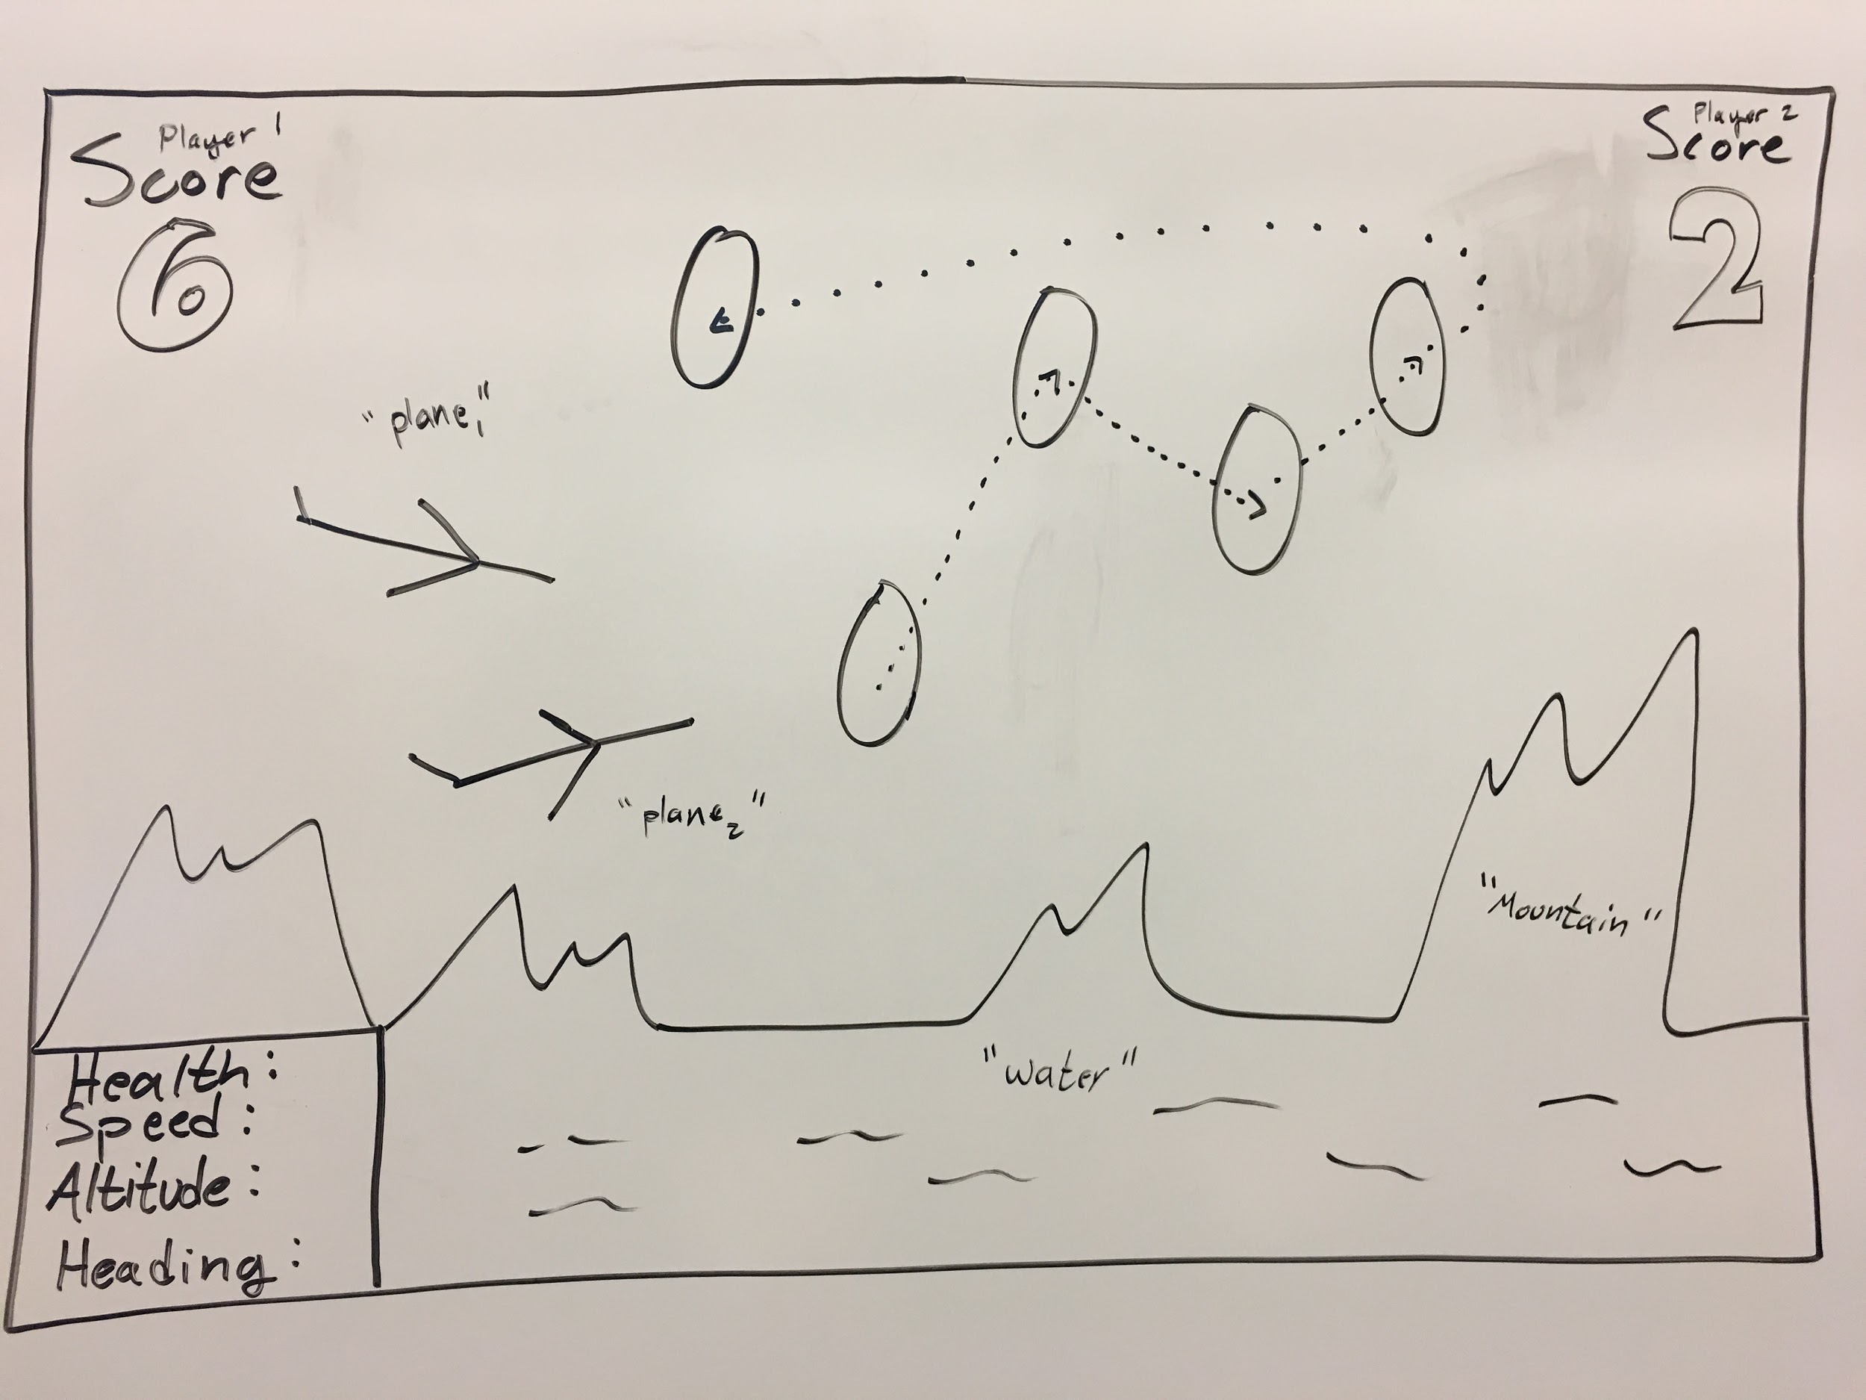

**1. Physics**

Final Flight will implement 3D physics so that the planes are able to navigate along the Y axis for flight while also being affected by the planet’s gravity. The rings will appear above the water (positive Y axis) and within a confined space in the XZ plane. The projectiles that each ship are able to shoot will use collision detection to accurately decrease the remaining health of the ship that has been hit by the projectile, when it makes contact. Because these projectiles will likely be modeled after some sort of blaster device they will shoot in a linear fashion and will not be affected by the gravity of the planet.

**2. Artificial Intelligence**

Final Flight will have the option to be played against the game’s artificial intelligence or another player on a split-screen setup. As such, AI will only be present if the option to play against an AI is chosen at the beginning of the game. This AI will navigate directly to the next ring unless the user’s aircraft ends up flying within a predefined area where the AI will then attempt to shoot the plane down for a random amount of time before focusing back on getting to the next ring. There will also be a decision for the AI to make on whether or not it wants to chase down the enemy plane, as of now this decision will be based on two factors: one, if the enemy is directly within a small line of sight and easy to target and two, if the enemy has a greater score than the AI.

**3. Gameplay & UI**

In Final Flight the primary objective of the game will be to navigate your ship through each ring as they randomly appear on the map. There will potentially be a mini map or some sort of direction identification so that while you are flying, if you can not see the ring, you will be able to find it. Once the user has navigated through a ring they receive a point, it is at this point that the objective becomes taking down the enemy ship. Once an aircraft has gone through a ring it will disappear and another will appear, so only one player will get a point from each ring. The end game is triggered when one of the ships is destroyed so if a player is in the lead they can then try to shoot down the enemy and thereby win the game, but if the enemy travels through two rings before they are shot down they would still win the game if they were destroyed.

**4. Networking**

Final Flight will be a one or two player game. If the two player option is selected two people will play using different sets of keys on a keyboard, there will not be real time networking in the game, however each person could get their own keyboard or play together as the controls will be split between WASD and the directional arrows.

**5. Sounds**

Since Final Flight will be loosely based around Star Wars we will be trying to find and use sounds from the cinematic franchise for our ships, projectiles, and potentially background music.